Sri Krishna Arts and Science College



PROJECT TITLE --World Bank Economic Indicator

NAME – NIVASHINI S
CLASS – B.COM CA (COMPUTER APPLICATION)
ROLL NO – 24BCO237
DEPARTMENT – COMMERCE CA & BA

S.NO | INDEX | PAGE NO
1 | About | 3
2 | Analysis | 4
3 | Dashboard | 5
4 | Query | 15

About :
This Power BI dashboard shows important economic data for different countries using information from the World Bank. It helps to understand how countries are performing financially and economically.
Key points in the dashboard:
- Economy: Shows GDP, GDP per person, and yearly GDP growth. Highlights countries with fast growth or negative growth.
- Government and Debt: Shows government spending, revenue, and debt. Helps identify countries in deficit or with high debt.
- Inflation: Shows inflation rates using CPI and GDP deflator. Flags countries with high inflation.
- Other data: Includes GNI, unemployment rate, tax revenue, and interest rates where available.
- Extra info: Some columns show categories like GDP growth type, fiscal status, or inflation risk for easy understanding.
This dashboard lets users compare countries, track trends, and see which countries are doing well or facing challenges. The data is cleaned and organized to make it simple and clear.

Analysis :
The dashboard shows how countries are performing economically over the years. We can see:
- GDP trends: Some countries have steady growth, while others face negative GDP growth in certain years.
- Fiscal health: Countries with high government spending but low revenue are often in deficit.
- Debt and deficits: High public debt and negative current account balances show which countries are financially vulnerable.
- Inflation: Countries with very high inflation may face economic instability, affecting purchasing power and growth.
- Employment and income: Unemployment rates and GDP per capita indicate the standard of living and economic well-being.
By using this dashboard, we can compare countries, identify risks, and make informed decisions based on real economic indicators.

Dashboard :
Main Dashboard :
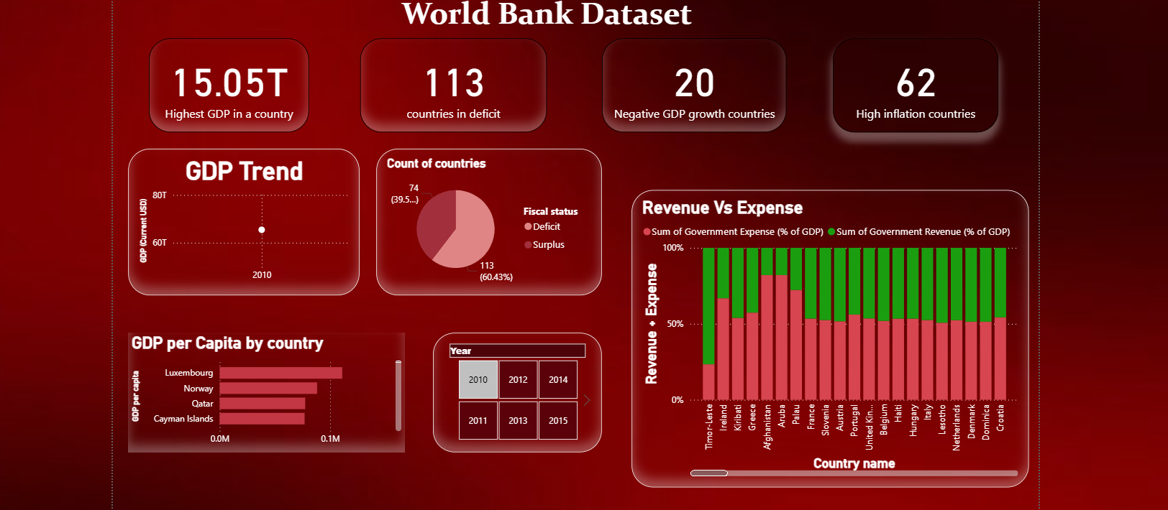

Year 2010
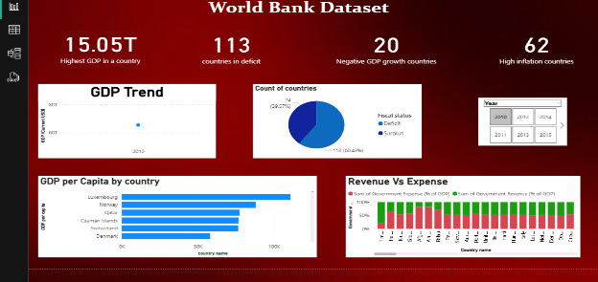

Year 2011
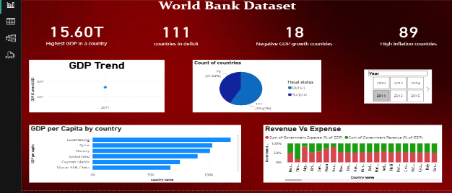

Year 2012 :
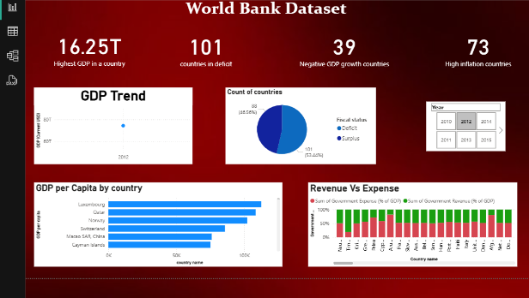

Year 2013 :
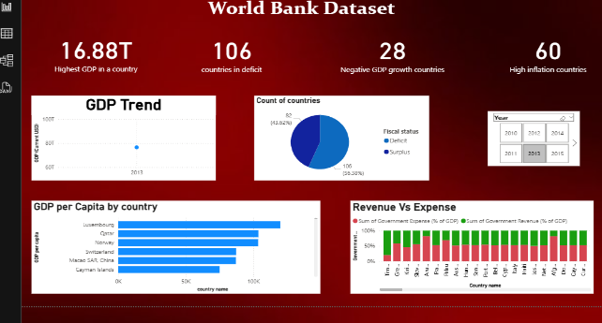

Year 2014 :
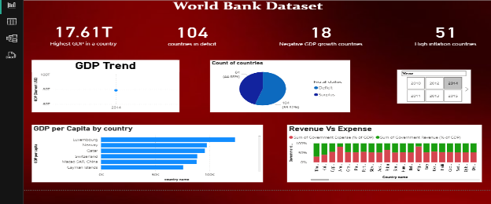

Year 2015 :
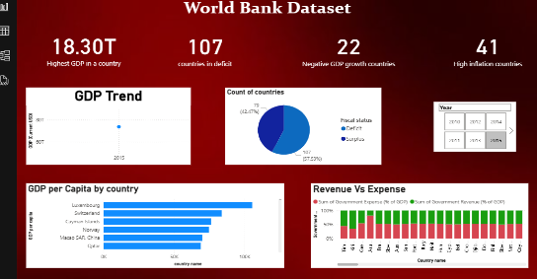

Year 2016 :
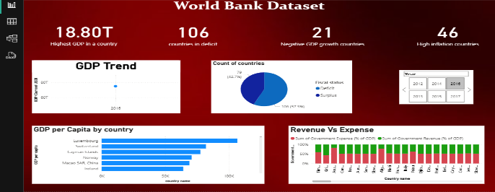

Year 2017 :
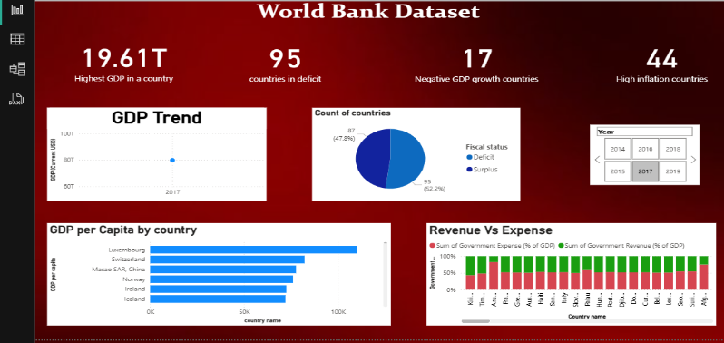

Year 2018 :
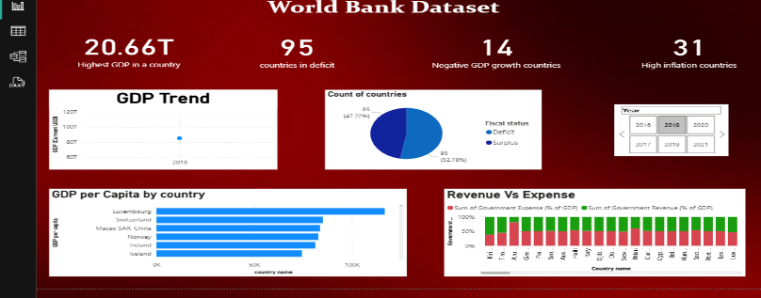

Year 2019 :
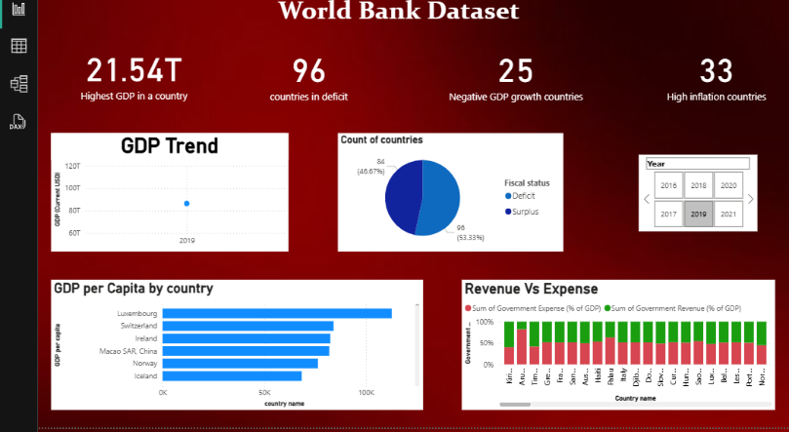

Year 2020 :
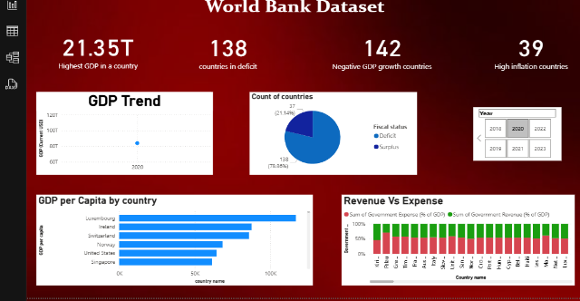

Year 2021 :
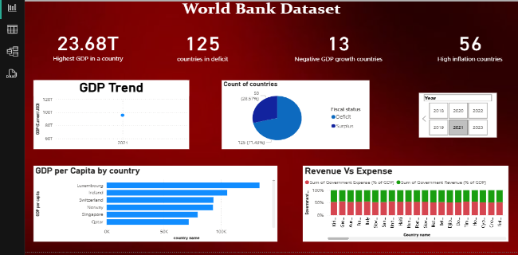

Year 2022 :
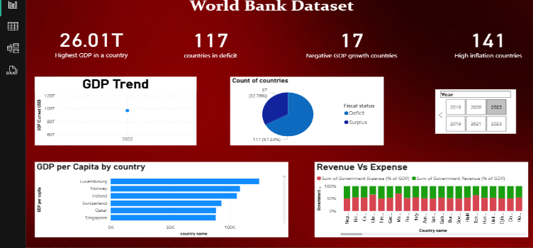

Year 2023 :
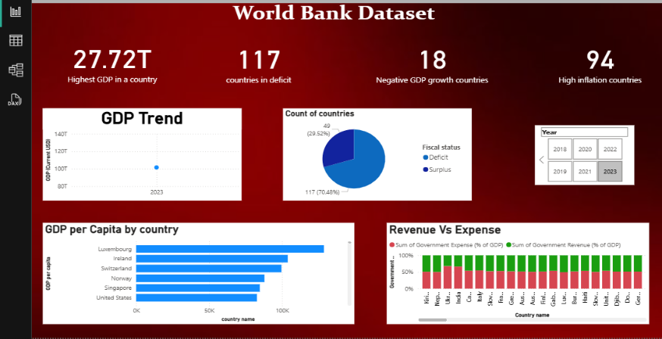

Line chart :
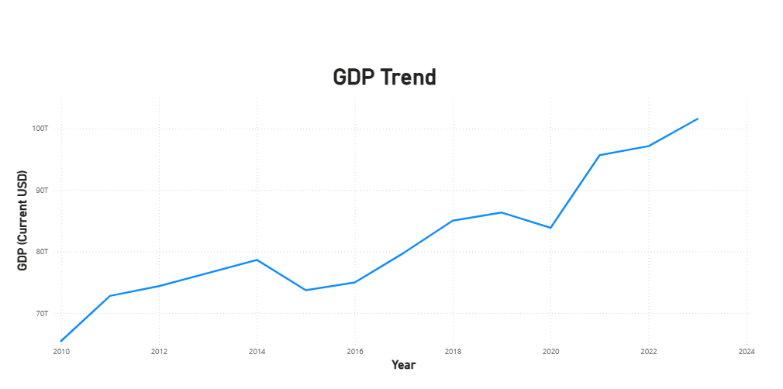
The line chart shows the GDP (Current USD) of countries over time.
The X-axis represents the year, and the Y-axis represents the GDP value.
This visual helps analyze GDP trends and growth patterns across years.

Bar chart :
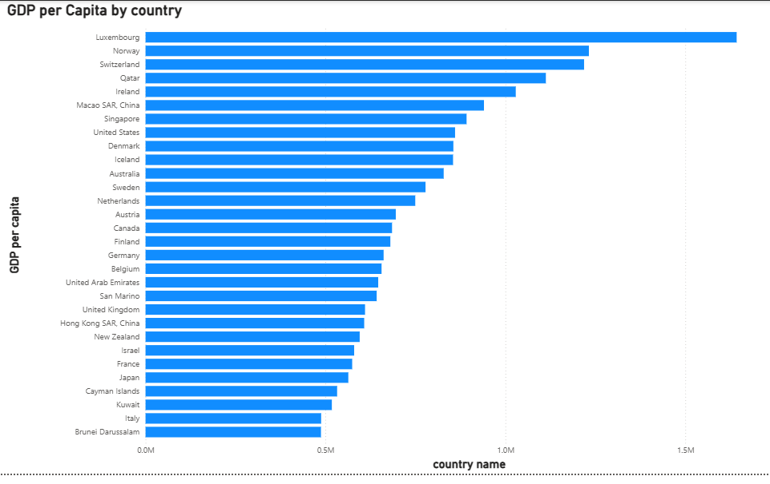

The bar chart displays GDP per Capita for each country. The X-axis shows the GDP per Capita values, and the Y-axis lists the country names. This visual helps compare the economic output per person across different countries.

Column chart :
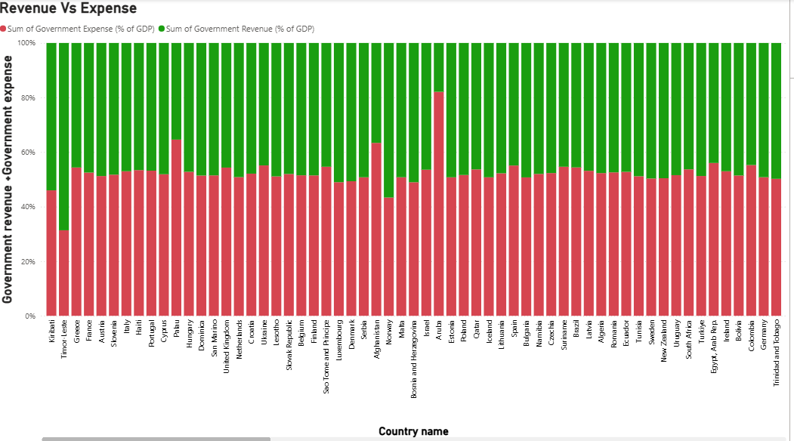
The column chart compares Government Revenue and Government Expenses (% of GDP) for each country. Each column shows the relative size of revenue versus expenses, making it easy to spot surpluses or deficits. This visual helps analyze the fiscal health and financial management of countries at a glance.

Pie chart :
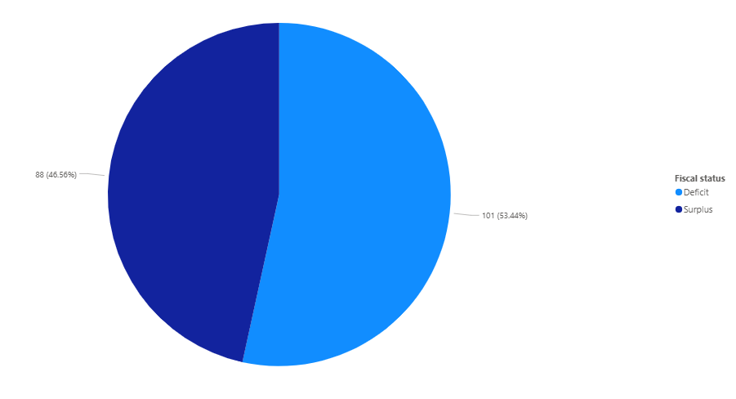
The pie chart shows the distribution of countries based on their Fiscal Status. Each slice represents the number of countries that are in Surplus, Deficit, or Balanced. This visual helps quickly understand the overall fiscal health of countries in the dataset.

Highest GDP in a country :
Highest GDP in a country = MAX(‘world bank data’[GDP (current USD)])
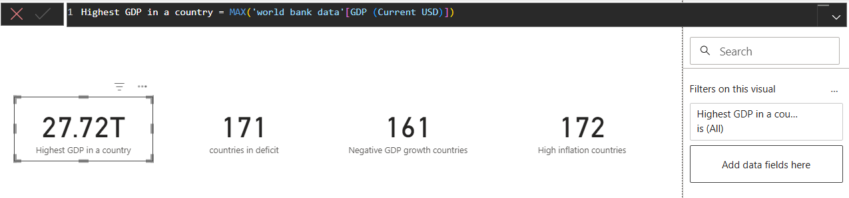
Highest GDP in a Country was created as a new measure using the MAX function on GDP (Current USD). This identifies the country with the largest GDP in the dataset. It helps highlight the top-performing economy for comparison and analysis in the dashboard.

Countries in deficit :
Countries in deficit = CALCULATE(DISTINCTCOUNT(‘world bank data’[country_name]),’world bank data’[Fiscal balance]<0)
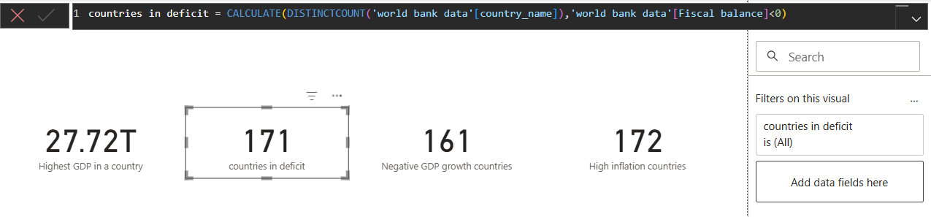

Countries in Deficit was created as a new measure using CALCULATE with DISTINCTCOUNT on country_name filtered by negative Fiscal Balance. This counts each country only once that is running a fiscal deficit. It helps clearly identify and visualize the number of deficit countries in the dashboard.

Negative GDP growth countries :
Negative GDP growth countries = CALCULATE(DISTI NCTCOUNT(‘world bank data’[country_name]),’world bank data’[GDP Growth (% Annual)]<0)
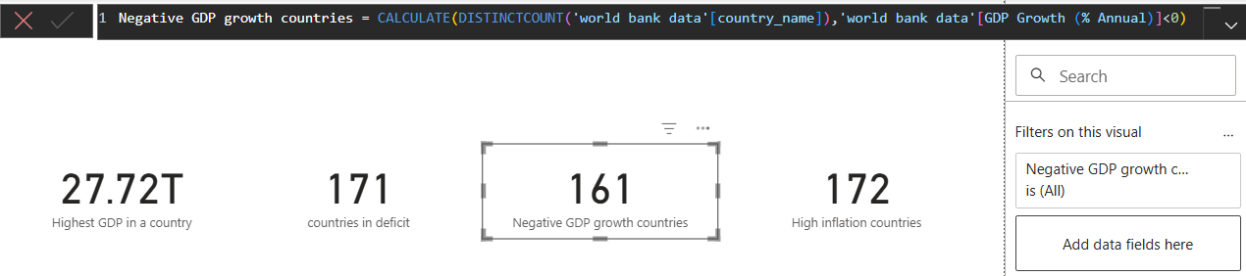

Negative GDP Growth Countries was created as a new measure using CALCULATE with DISTINCTCOUNT on country name filtered by negative GDP Growth. This ensures we count each country only once, even if there are multiple entries per year. It provides an accurate number of countries experiencing economic contraction for analysis and visuals.

High inflation countries :
High inflation countries = CALCULATE(DISTINCTCOUNT(‘world bank data’[country_name]),’world bank data’[Inflation (CPI %)]>5)
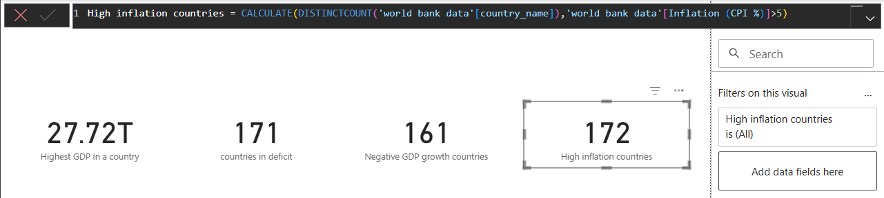

High Inflation Countries was created as a new measure using a query that filters countries with high inflation values. The measure counts how many countries fall into the high-inflation category. This helps quickly highlight which countries face severe inflation concerns in the dashboard.

Debt column :
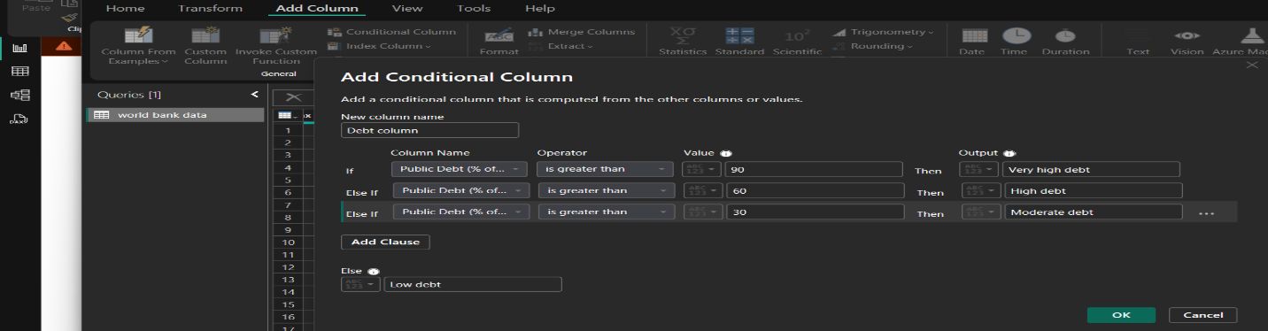

The Debt column was created using Add Conditional Column to categorize countries based on their Public Debt (% of GDP). We applied conditions to group them into levels such as Low, Medium, or High debt. This helps simplify debt analysis and makes comparisons clearer in visuals.

GDP Growth category :
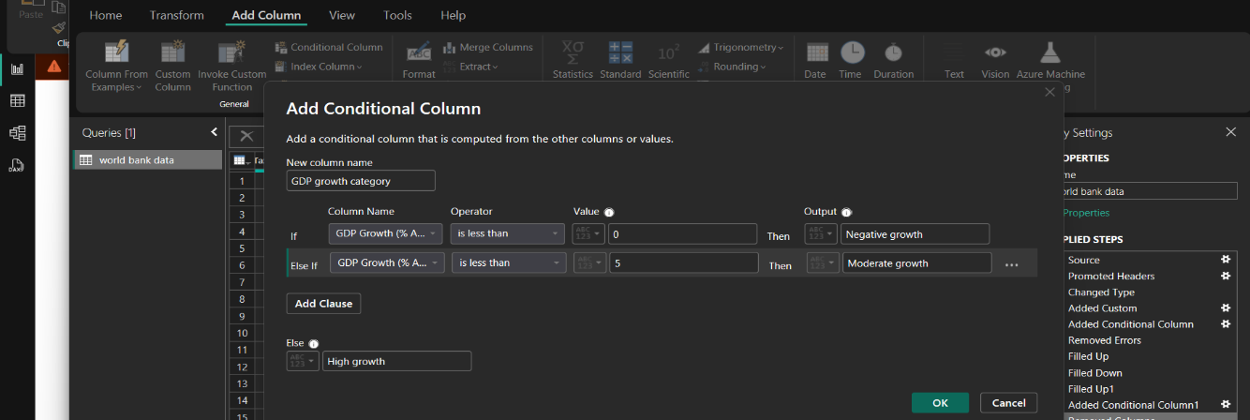
The GDP Growth Category was created using Add Conditional Column based on GDP Growth (% Annual). We set conditions to classify each country into Negative Growth, Moderate Growth, or High Growth. This makes it easier to analyze and visualize economic performance.

Fiscal column :
= [#”Government Revenue (% of GDP)”]-[#”Government Expense (% of GDP)”]
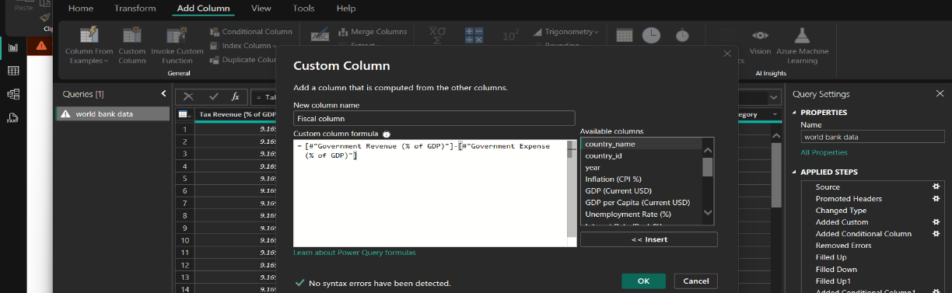

The Fiscal column was created using Add Column by calculating Government Revenue − Government Expense in a custom column.
This gives the actual fiscal balance value for each country. It helps identify whether a country is running a surplus or deficit based on the result.

Inflation risk :
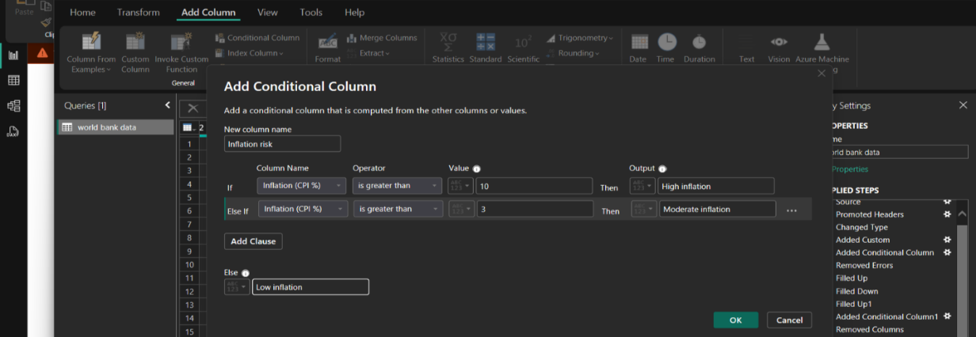
Inflation Risk was created using Add Column, where we applied an IF condition on the inflation values. This new column classifies countries into High, Medium, or Low inflation risk categories.

GDP growth :
GDP Growth = COUNT(“world bank data”[GDP growth category])
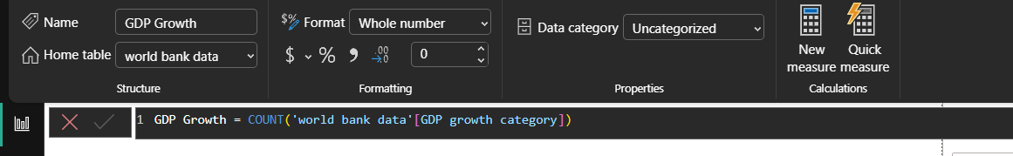
GDP Growth was created as a new measure using a count of countries based on their GDP Growth values. This measure helps summarize how many countries fall under different growth levels. It makes the analysis clearer when used in visuals like charts and cards.

GDP growth category :
GDP Growth categories = IF('world bank data'[GDP Growth (% Annual)]<0,"Negative growth",IF('world bank data'[GDP Growth (% Annual)]<5,"Moderate growth","High growth"))
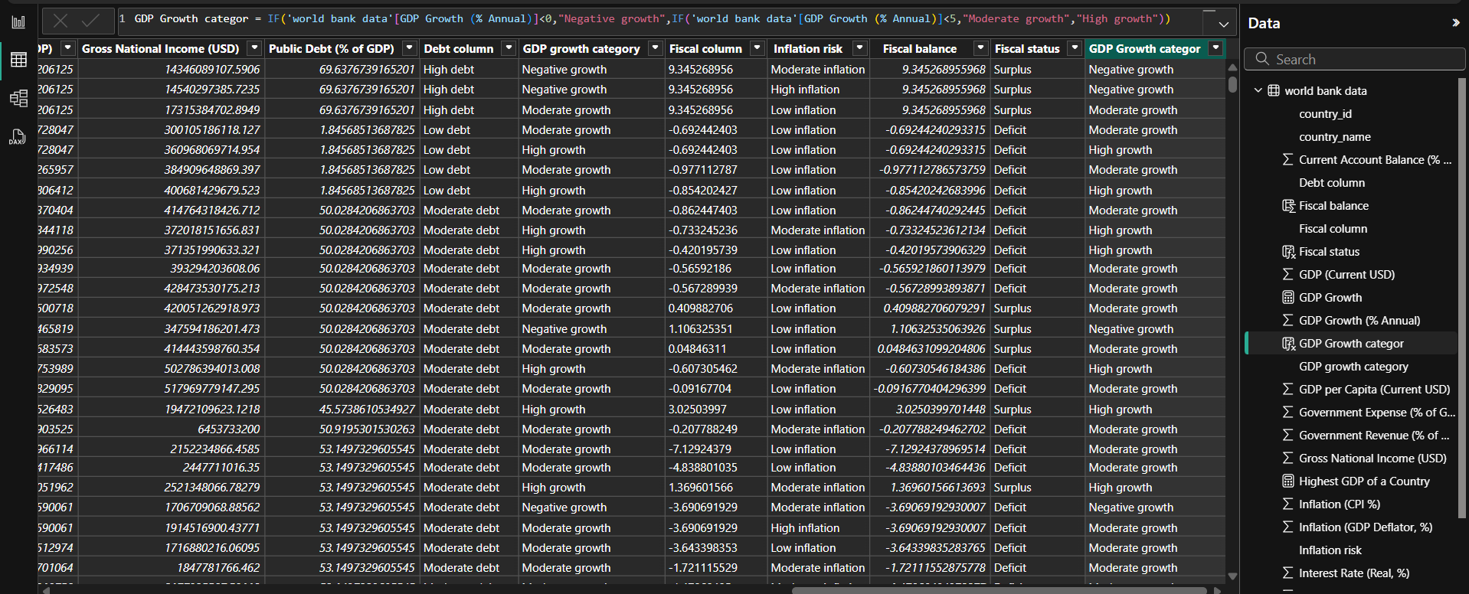
GDP Growth Category was created in the table view using an IF statement based on the GDP Growth (% Annual) values. The IF logic classified each country into Negative Growth, Moderate Growth, or High Growth depending on their growth rate. This categorization helps make economic comparisons easier and more meaningful in visuals.

Fiscal balance :
Fiscal balance = 'world bank data'[Government Revenue (% of GDP)]-'world bank data'[Government Expense (% of GDP)]
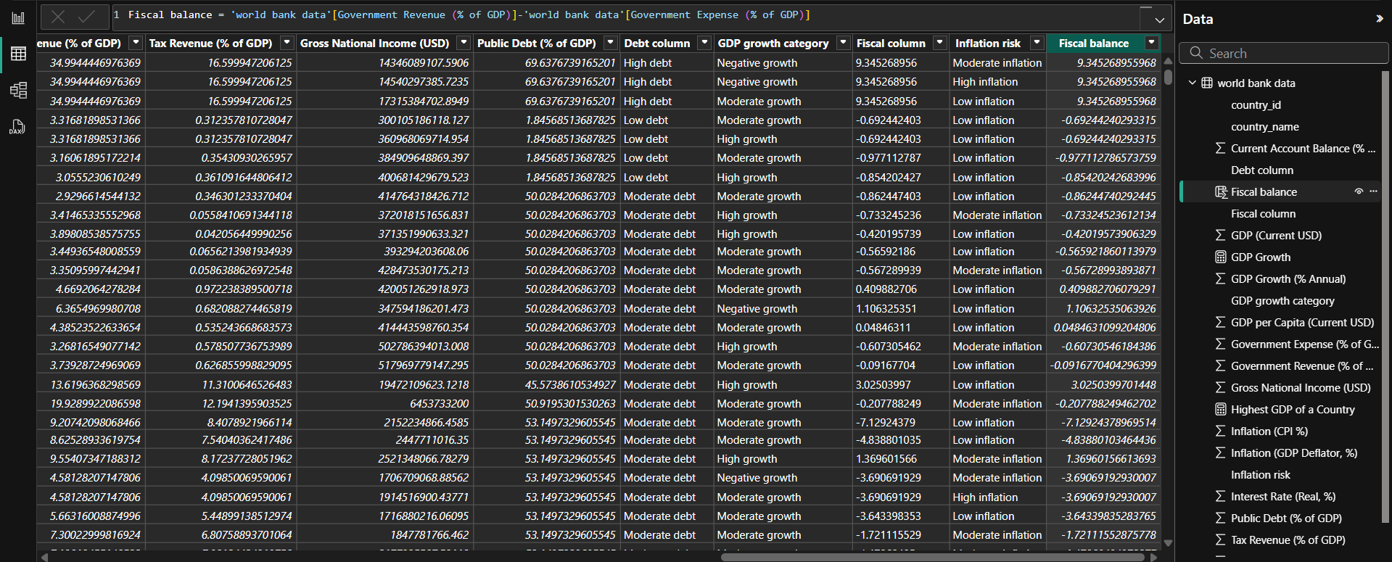
Fiscal Balance was created in the table view by comparing Government Revenue and Government Expense. We used these two values to calculate whether a country is running a surplus, deficit, or is balanced.
This helps classify each country’s fiscal health and makes the analysis easier to visualize.

Inflation risk :
Inflation_risk = IF('world bank data'[Inflation (CPI %)]>5,"High inflation","Normal inflation")
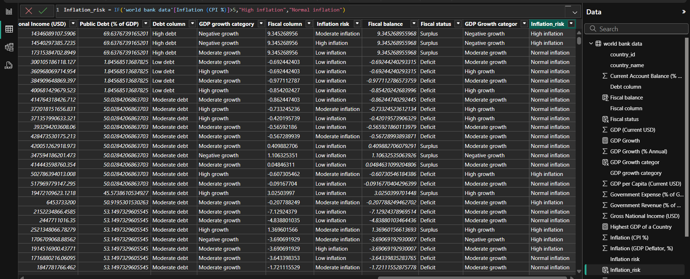

We created Inflation Risk using an IF condition to categorize countries based on their inflation levels. This helps convert raw inflation numbers into meaningful groups like High, Medium, and Low risk. By doing this, analysis and visuals become easier, since we can compare countries by risk level instead of just numbers.

